

Inventory Management System Project
Course: Introduction to Computing Science II
Instructor: Dr. Mehak Khurana
Semester: Fall 2025-2026

Submitted By:
Name: Borna Hasanzadeh
ID: 20240005688
Name: Mohammad Nader GhasemiFard
ID: 20240005892
Name: Kamyar Bakhshizadeh
ID: 20240005258
Name: Omar Khoori
ID: 20240005576

Problem Statement
While doing our project we faced multiple errors which made us realize how hard it is to manage inventory manually. First problem we faced was when we were adding a product with the same ID, instead of showing an error it was adding the product. So when we would search for the ID it would only show the first product and not the second. This made us realize that there’s an error in our code when we were in Phase 3, testing the code.
Another problem we faced was when for example we were adding a product, we were adding the id and the name and in the middle we decided to cancel and not add the product, we didn’t have an option for that.

Objectives
Make a simple Java program that helps keep track of products in a store.
Create separate classes so everything is organized and easy to manage.
Let the user do basic actions like add, view, update, delete, and search for products.
Use exception handling so the program doesn’t crash when someone enters something wrong.
Test everything to make sure all the menu options work the right way.
Make the program easy to improve later.

Results & Output
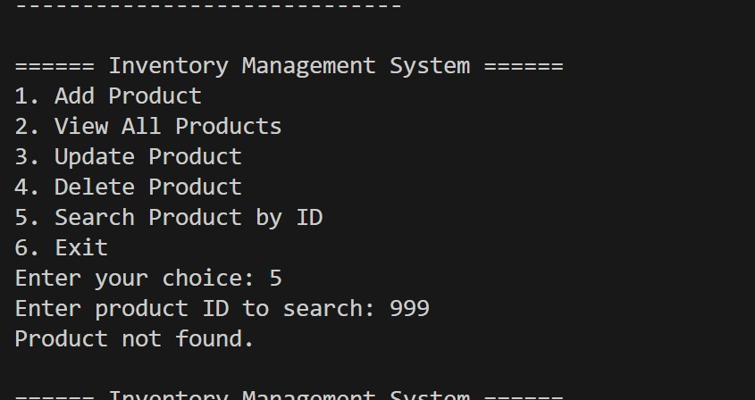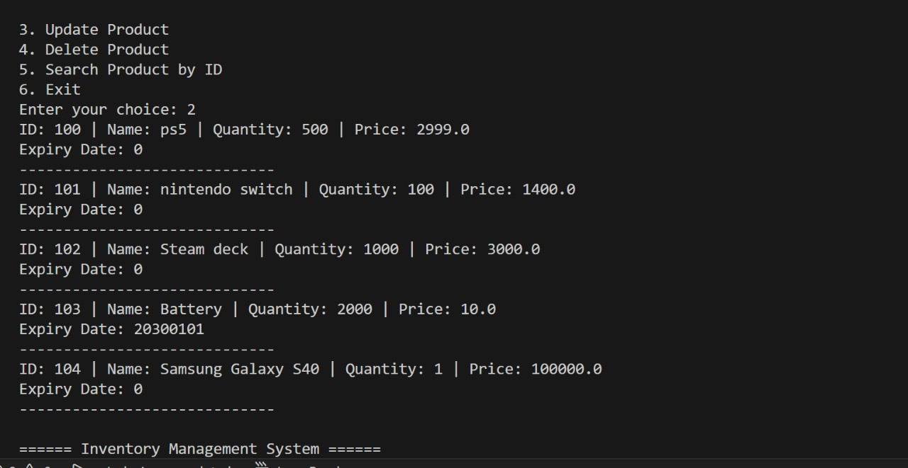

Java Code

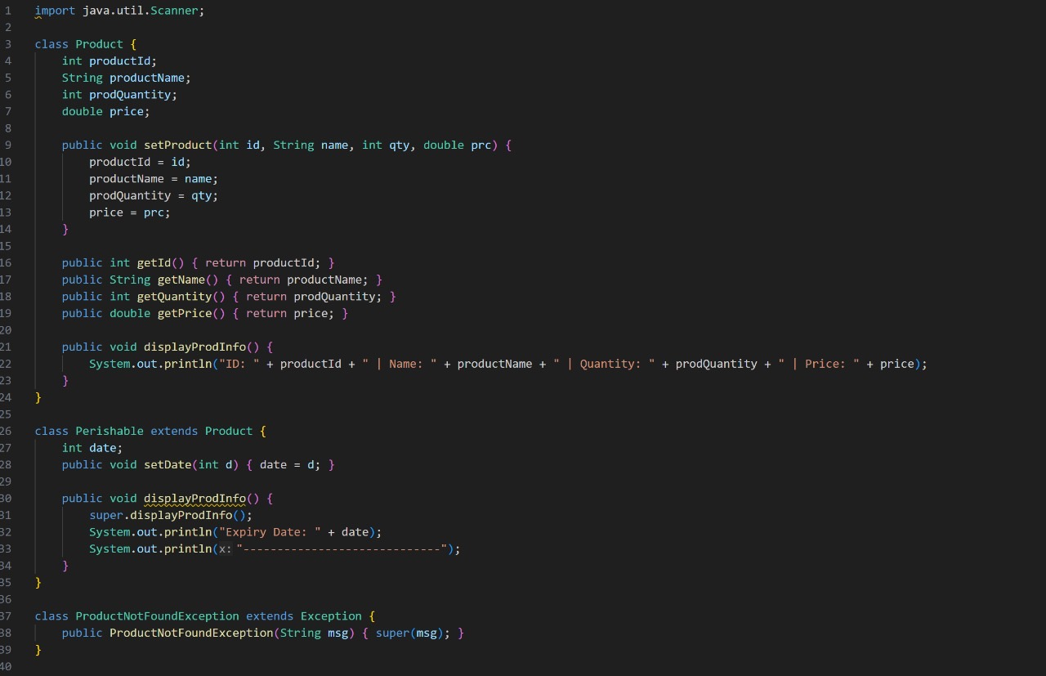

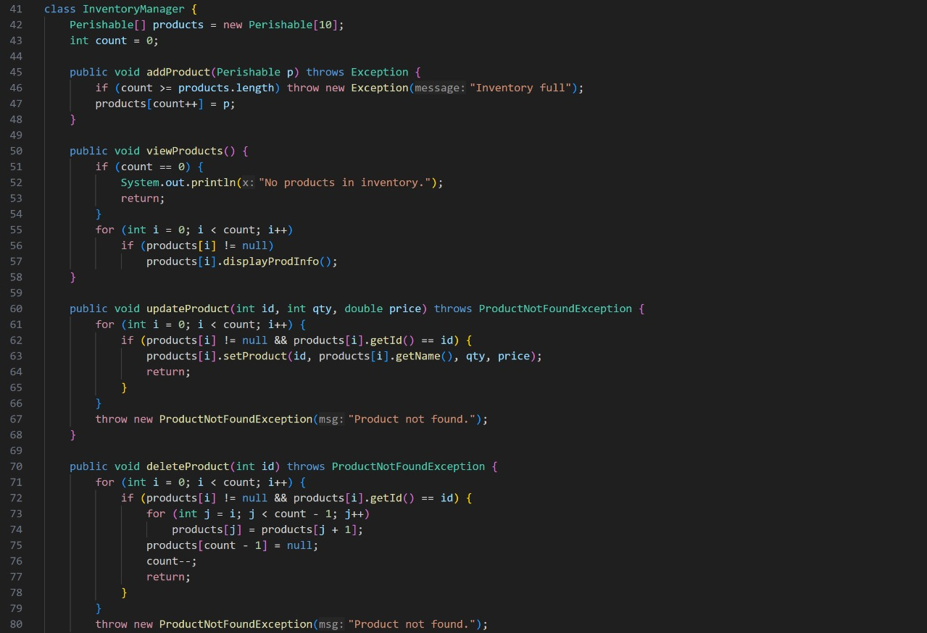

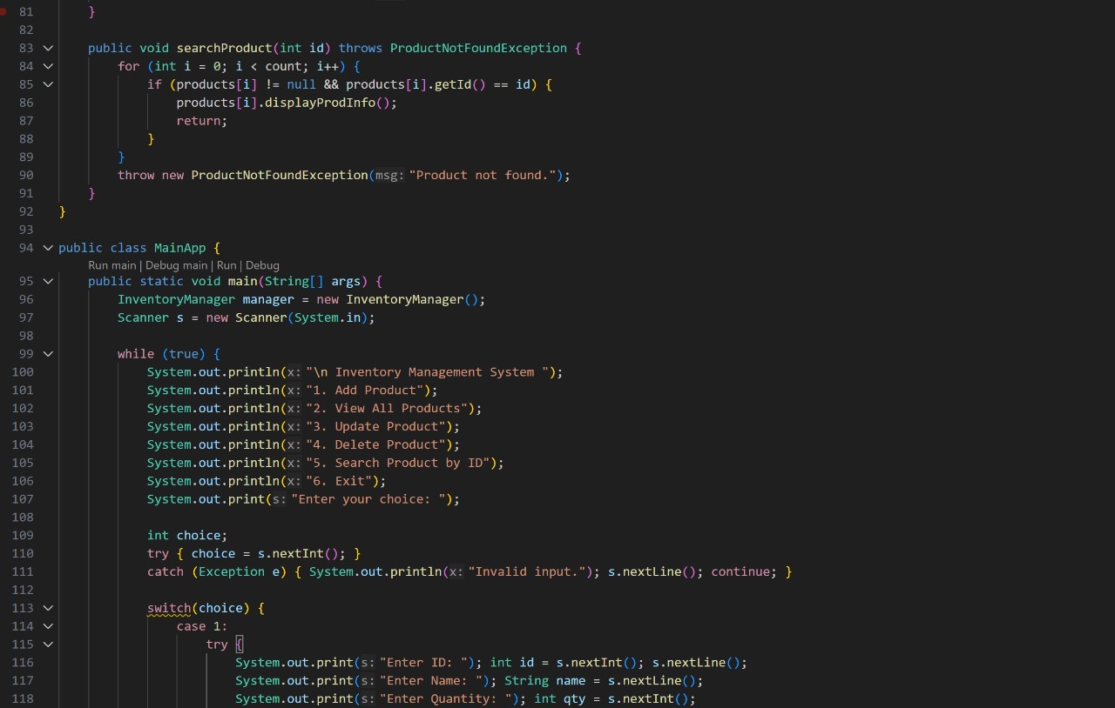

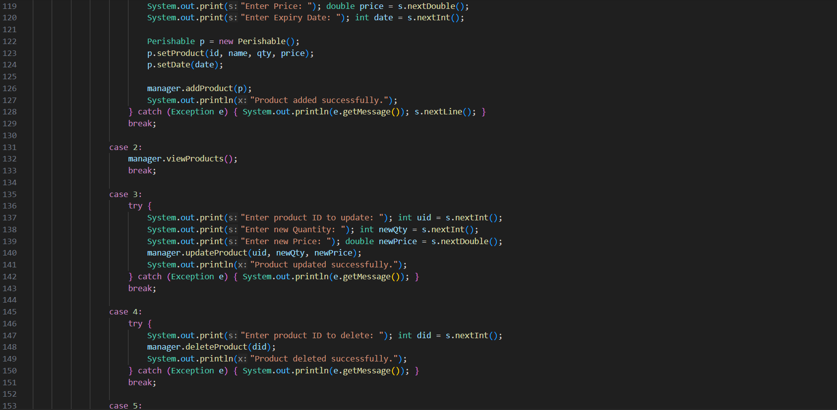



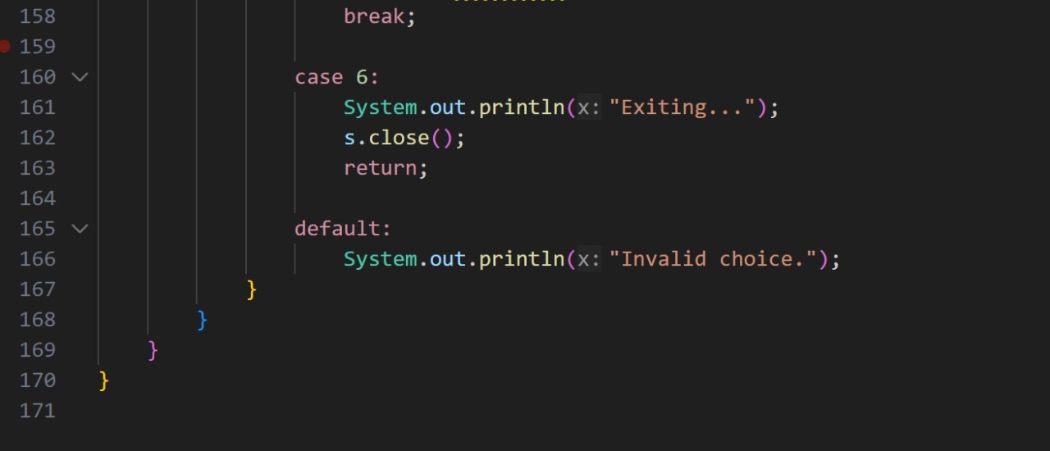

Class Diagram

